DEPARTMENT OF ENVIRONMENTAL HEALTH
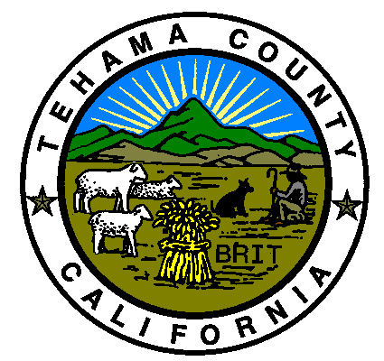
633 WASHINGTON STREET, ROOM 36
RED BLUFF, CA 96080
Phone (530) 527-8020 Fax (530) 527-6617

Tim Potanovic, REHS
Director

July 31, 2026

Dear property owner,
Your property has been identified as having been damaged or destroyed by the Dixie or McFarland fires during the 2021 wildfire season. One of the first steps toward recovery is getting your property cleared so you can begin the process of re-building. The first step in clean-up (Phase 1) includes state and local officials coming onto your property to identify and remove potentially hazardous materials. This includes items like batteries, propane tanks, asbestos and paints. The second step (Phase 2) will include ash and debris removal from burned structures and hazardous tree removal.
Because of the hazardous nature of ash and burn debris, it must be handled properly and disposed of in a certified waste management facility. Removing and disposing of this material is expensive, but the Consolidated Debris Removal program, also know as the Right of Entry or ROE program can help. The ROE program has no cost to the homeowner. To participate in the ROE program, property owners must enroll. Once enrolled, contractors will remove debris and hazard trees at no out-of-pocket cost to the homeowner. There is a coordination of insurance benefits for those properties that were insured, but even if insurance benefits related to debris removal are exceeded, there is no additional cost to property owners. Properties that were not insured are also eligible to participate in this program but you must sign up. Contractors operating under state oversight will perform all work and hauling.
When completed, the ROE will allow the County, State and its contractors to enter the affected property to manage all aspects of ash and structural debris assessment and disposal on behalf of the property owner. Phase 2 will include soil scraping to remove contaminants, soil confirmation sampling (including heavy metals testing), erosion control and hazard tree removal. Please note that this program will remove hazard trees even if your structure was not damaged.
If you choose not to enroll in the ROE program, you are still responsible for meeting the same clean-up standards on your property. Tehama County has an Alternative Debris Removal Program that defines the clean-up standards required by the property owner. Under this scenario the property owner must hire a contractor and clean up their property at their own expense. Site testing must be completed to ensure the soil is clean. Estimates for this clean-up range from $70,000 - $100,000 dollars. Burn debris must be disposed of in Anderson or Wheatland.
To enroll in the ROE program, property owners will need to complete a permit package called the Right of Entry packet or ROE. A packet is attached to this letter, it is also available on the Tehama County website (https://www.co.tehama.ca.us/government/departments/environmental-health/ ) and the Tehama County OES website (https://tehamaso.org/emergency-services/).
Property owners must participate in either the ROE program or the Alternative Debris Removal Program. Failure to do so may result in your property being deemed a public nuisance and abatement proceedings being brought against you.
Please note, the following information is required to complete the ROE form:
- Residential Debris Removal Right-of-Entry Permit
- Government issued ID (drivers license, passport, etc)
- Insurance Policy
  - Declaration page
  - Debris removal coverage page
- Assessor’s parcel number (APN)
- Signatures of all owners, trustees or Power of Attorney
- Trust or LLC Documents (if applicable)
  - 1st page of trust, LLC, etc
  - Signature authorization page
  - Power of Attorney signature page
- Signed and notarized document for authorized agent (only required if property owner is not signing)

All owners, trustees or signatories must sign the Residential Debris Removal Right of Entry Permit. As winter is rapidly approaching, we would like to have all ROE forms returned by November 1, 2021. Properties must be enrolled by November 15, 2021.
If you have any additional questions, you may email Tehama County Environmental Health at environmentalhealth@co.tehama.ca.us. We appreciate your cooperation in this difficult time.
Sincerely,

Tehama County Environmental Health Department

