
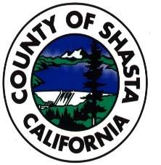
Shasta and Tehama Counties
Joint Voting Accessibility Advisory Committee/ Language Accessibility Advisory Committee
Thursday, October 5th, 2023
9:00 AM
Shasta County Clerk
1450 Court Street, Suite 263
Redding, CA 96022

VAAC Agenda Items:
1. Introductions/Roll Call
2. Approval of Minutes from 8/10/23
3. Final approval of the VACC application
4. Demo of new voting system in Shasta / RAVBM
5. Recruitment of members
6. Accessibility training for poll workers
7. Outreach to voters regarding the new system
8. Adjourn to convene as the LAAC
LAAC Agenda Items:
1. Introductions/Roll Call
2. Approval of Minutes from 8/10/23
3. Final approval of the LACC application
4. Survey for Spanish speaking voters – not completed
5. Report out regarding Tehama attendance at the Hispanic Heritage celebration
6. Recruitment of members
7. Next meeting date/time

